Order Of Service

Opening Hymn: TLH 151 vs 1-4

Reading: Lent IV

The History of the Passion of our Lord

Sermon Hymn: TLH 153

Sermon Text: Daniel 3:26-30

Out Of The Fiery Furnace

Prayer

Holy Communion

The Lord's Prayer

The Blessing

Closing Hymn: TLH 151 vs 5-7

* * * * * * * * * * * * *

Koinonia Hour

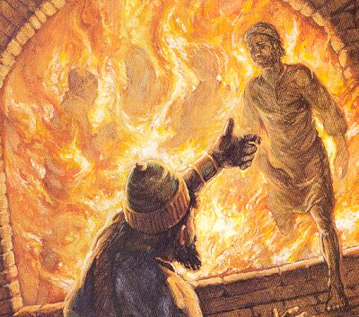

Out Of The Fiery Furnace

Water
Of
Life

4 March 2018

W A T E R O F L I F E

Independent Christian Church—Conservative Lutheran Doctrine

Worship Service: 9:30 a.m. Bible Study: 10:45 a.m.

Larry Cooper, Pastor E-Mail address:
111 N. Ridge Road lcooper@wateroflife.cc
Coon Valley, WI 54623 Web Site:
Phone: (608) 452-2105 www.wateroflife.cc

* * * * * * * * * * * * * * * * * * * * * * * * * * *

Sermon Text: Daniel 3:26-30

Out Of The Fiery Furnace

* * * * * * * * * * * * * * * * * * * * * * * * * * *

Daniel 3:26 Then Nebuchadnezzar came near to the mouth of the burning fiery furnace, and spake, and said, Shadrach, Meshach, and Abednego, ye servants of the most high God, come forth, and come hither. Then Shadrach, Meshach, and Abednego, came forth of the midst of the fire.
:27 And the princes, governors, and captains, and the king's counsellors, being gathered together, saw these men, upon whose bodies the fire had no power, nor was an hair of their head singed, neither were their coats changed, nor the smell of fire had passed on them.
:28 Then Nebuchadnezzar spake, and said, Blessed be the God of Shadrach, Meshach, and Abednego, who hath sent his angel, and delivered his servants that trusted in him, and have changed the king's word, and yielded their bodies, that they might not serve nor worship any god, except their own God.
:29 Therefore I make a decree, That every people, nation, and language, which speak any thing amiss against the God of Shadrach, Meshach, and Abednego, shall be cut in pieces, and their houses shall be made a dunghill: because there is no other God that can deliver after this sort.
:30 Then the king promoted Shadrach, Meshach, and Abednego, in the province of Babylon.

